ART

Understanding in-betweenness
S. RAVI
FEBRUARY 06, 2020 15:33 IST

SHARE ARTICLE
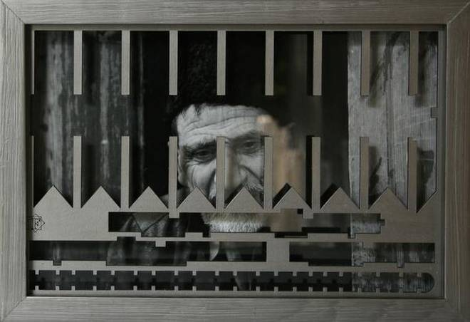
Capturing the pain: Veer Munshi’s work titled ‘How Green is my Valley’

An ongoing group-show tells meditative tales of migration
Blending aesthetic appeal with reality, the ongoing multi-media group show of Indian and foreign artists, “You Will Know Me: Migration Stories”, forces viewers to introspect. Curated by Tara Sabharwal at Art Alive Gallery, the exhibition displays a variety of works in diverse medium and deals with the critical issue of displacement of humankind.
Be it the historical colonisation by the West, neo-colonialism, climate change, war and poverty among others have resulted in the rise of refugees and a surge of xenophobia.
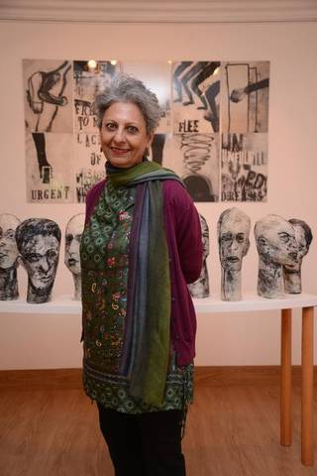
“The alien ‘other’ is not only demonised, but also turned into an existential threat,” observes Sabharwal. Being a migrant herself, who is constantly on the journey of self-discovery, made Sabharwal reflect on the human condition of refugees. “I saw in it an opportunity to explore and showcase the in-betweenness, space between two cultures where relationships and negotiations remain unfixed, in a state of constant transformation.”

Concerns of displacement

Sabharwal got together myriad artists hailing from different parts of the world whose works voiced the concerns of displacement of others or their community. Every member of the group agreed to take the show to their location, invite local artist and involve the community to keep the dialogue relevant and urgent. Thus, we have Ayisha Abraham bringing to fore the life of a Nepali guard in her city, Bengaluru; a short film by Ritu Sarin and Tenzing Sonam on the displacement of Tibetans; etchings by Mohammad Omer Khalil based on the book “Seasons Of Migration To The North” by Tayeb Salih; Barbara Beisinghoff, a German graphic artist paying homage to German Jewish poetess Gertrud Kolmar murdered in Auschwitz; abstract art by Miguel Angel Rivera using maps, European viruses and geometry dating back to pre-Columbian cultures referring to the colonialism of America, among other works.
Sabharwal’s own work, “Untitled”, a collage of acrylic on silkscreen is autobiographical in nature, showing people in boats, the horizon, and the sky. “It portrays the feeling of being alone even when you are in a group, though alone is in a meditative sense. It also represents a spiritual realm, an individual’s journey, with life undergoing constant transformation. Reflecting the vulnerability of refugees, it shows them looking longingly at the shore and horizon, signifying hope.”
Likewise, Haitian, Leslie Jean-Bart’s collage of six photographs, “Untitled”, is multi-layered and multi-referential. “It has a lot of unsaid, void and shunya. He plays with the sand-water, which even when brought together turbulently never meet. Thus we all are close but not together. The shadow in the work represents in-betweenness,” explains Sabharwal.
On the other hand, Sarojini Lewis’ “El Alamein” (1-6), print analogue photography with calligraphy in ink, is inspired by her grandfather’s migration from Shillong to multiple destinations during his British Army service. “It is a montage that talks about her roots, through her grandfather and parents,” remarks Sabharwal.

Fear and anxiety
Using photographs to narrate human emotions is Veer Munshi’s “How Green Is My Valley” (Grid 1-10). He clicked these images last August when Article 370 was abrogated. “With Internet and communication services suspended, I witnessed a number of people, especially youth, leaving for other States and cities, out of fear and anxiety about the future. That reminded me of the ‘90s, when I, in my 20’s, had to leave Kashmir, my home State. I realised that with the passage of time, nothing has changed, except my beard, which has turned grey,” he quips.
It is remarkable as the black and white pictures peek from the back of the frames with grills. “You feel that the faces peeping from behind a window with jaalis or grills, symbolising curfew and restriction,” clarifies Munshi. Denying that his works carry a political message, he says, “It is done purely from a human angle”.
Conveying effectively how the life of migrant changes, are Ayisha Abraham’s works in the show. While the short film “One Way”, tells us about Shyam Bahadur, who migrated to Bengaluru in 60s and works as a security guard, the images titled “Under The Ground”, show him living with his family in the basement of the residential complex where he works. Viewed in conjunction with the pictures titled “Between The Sky And The World”, the impact is significant, as they depict the lovely mountains and the verdure surroundings of the land, Bahadur has left behind. “I want viewers to feel the poignancy of a migrant’s life, and thus make us empathise with them,” says Abraham.
Being the daughter of Holocaust survivors, Tatana Kellner’s works bring out the anguish and state of refugees. In “Please Exit, Doors Are Closing”, digital prints, we see the situation of refugees in US. While the backpack represents refugees, words like courage, flee, unfulfilled dreams, show different facets of their life. Her trace monoprint on handmade paper installation, “Reconsider”, are human faces, sombre with sadness vivid in their eyes. “They are poetic pieces on humanness and their fragility,” notes Sabharwal.
Breaking the show’s theme, are the stunning works by Mary Ting. Her monoprint silkscreen titled “Hands, Feet, Beaks” raises concern about the extinction of animals due to climate change and global warming while “Have Your Heard?” (silkscreen with watercolour) showing fragments of human hands and bird heads, are metaphors of our dysfunctional world.
While agreeing that migration and refugees are in news, Sabharwal, says the show is not about making a statement. “One needs to understand that we don’t need the ‘other’ to know about self. In order to realise and recognise what I am, why is it imperative to have the other,” she asks. “There is a need to get over the insider-outsider mindset,” she urges.
(On until February 10, 11 a.m. to 7 p.m., Monday to Saturday, Art Alive Gallery, New Delhi)

